Portal & Navigation Rule

**Portal Rule**

* **Portal is an instance of Data Portal Class. A Portal rule can be created under User Interface Category.**
* **A portal includes Harness rule.**
* **Harness includes sections.**
* **Portal must be created in Data-Portal Class. Also the harness, sections and properties should be created in Data-Portal Classes.**
* **In portals the Harness rules gets executed on a primary page ‘pyDisplayHarness’**
* **In the manager portal the left navigation menu is been designed using the below navigation rule**

**Navigation Rule:**

**Navigation is a User Interface Rule. Navigation purpose is to Add Menu Names & Menu Actions.**

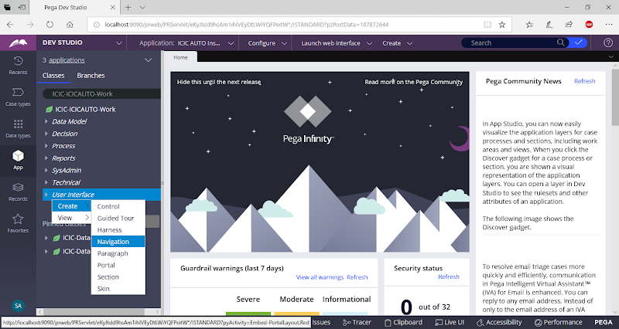

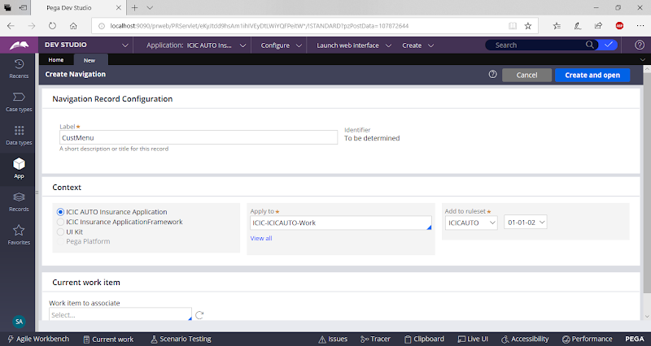

open

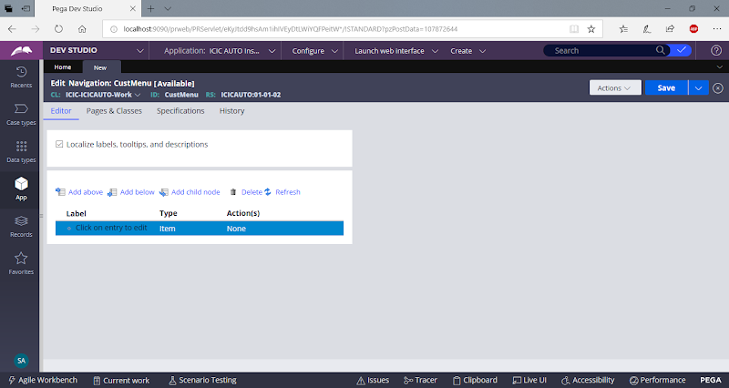

Double Click on Menu:

Add Text

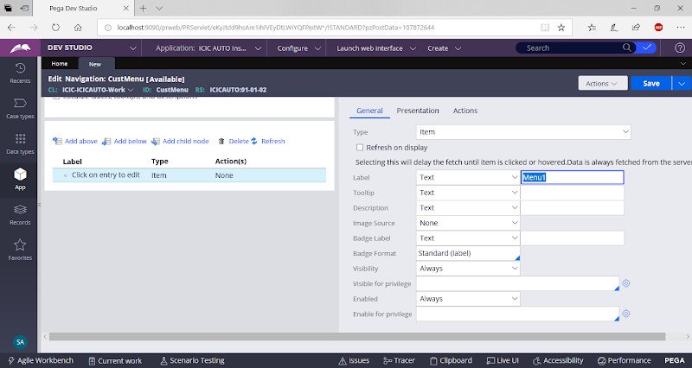

Go to Actions: Select Launch Local Action

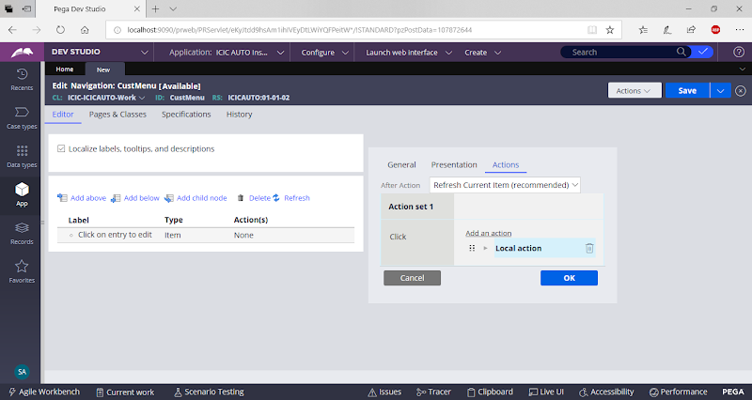

Fill Parameters

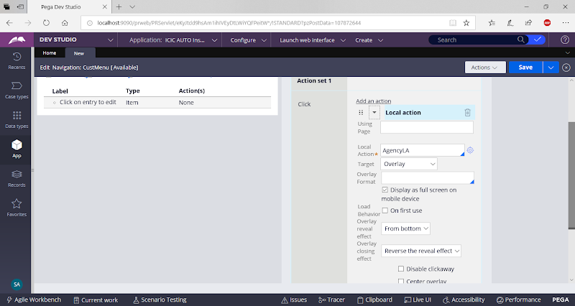

Click on Ok

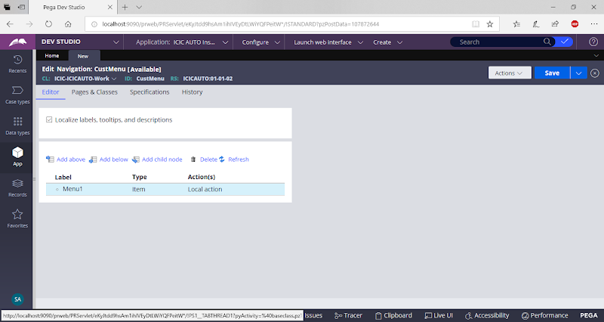

Add another Menu, Click on Add Below

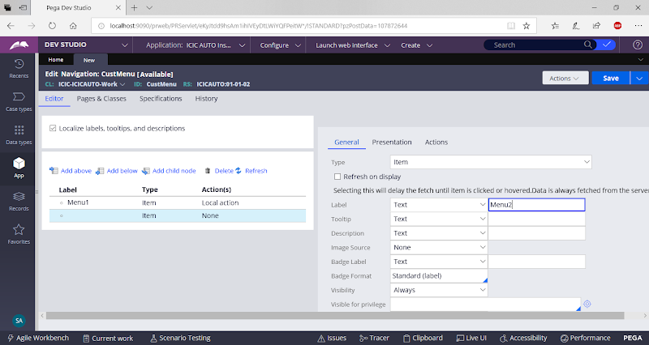

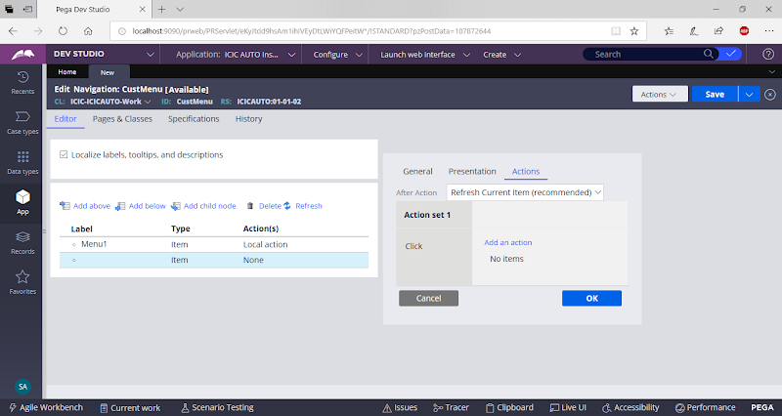

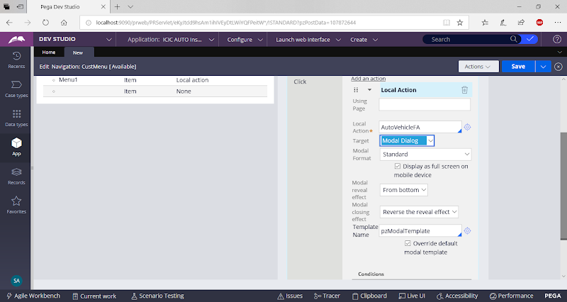

Click on Ok

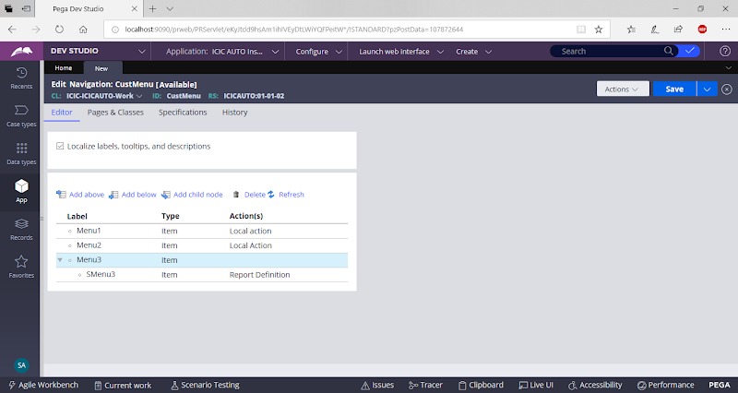

Save Navigation

Open Customer Section:

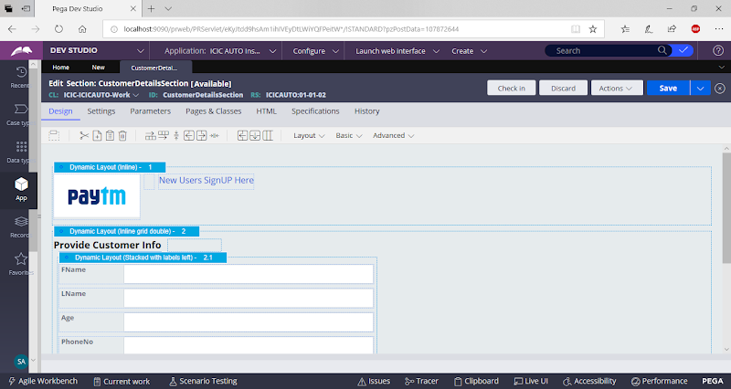

Add Menu Control

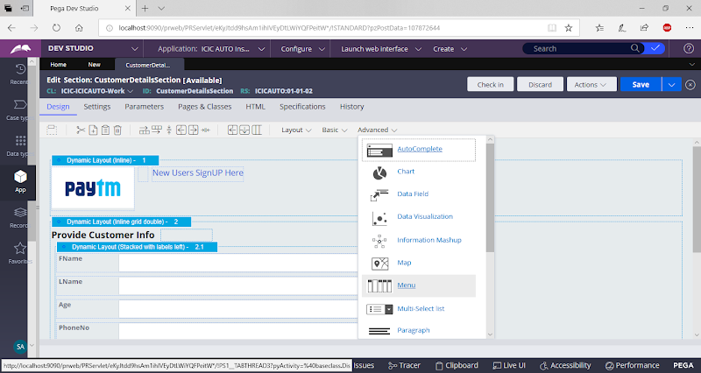

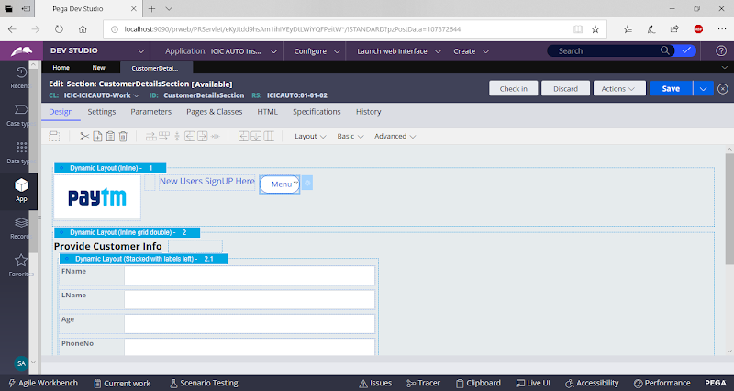

Change the Control to Button Control

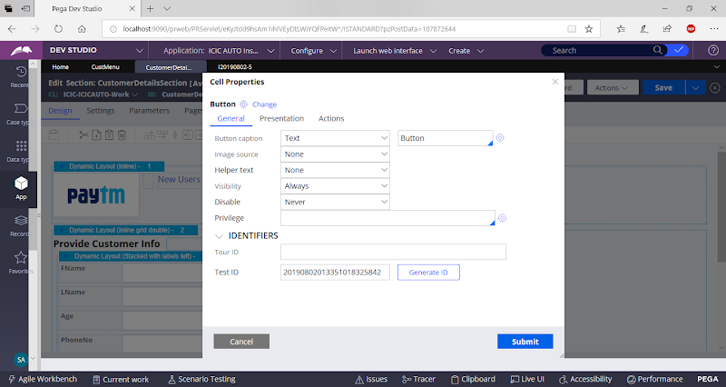

Change Label & Add Action

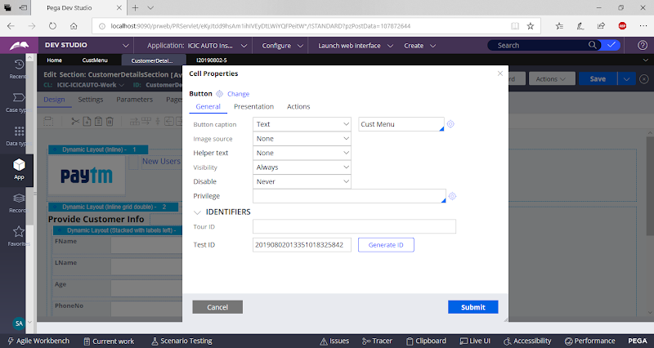

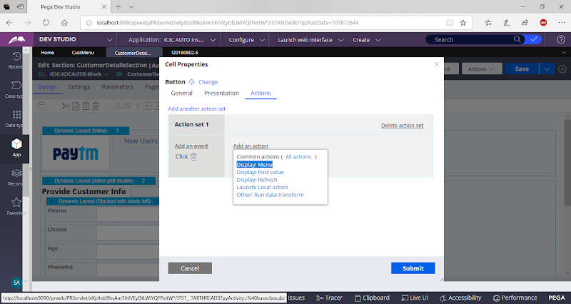

ActionName: Display Menu

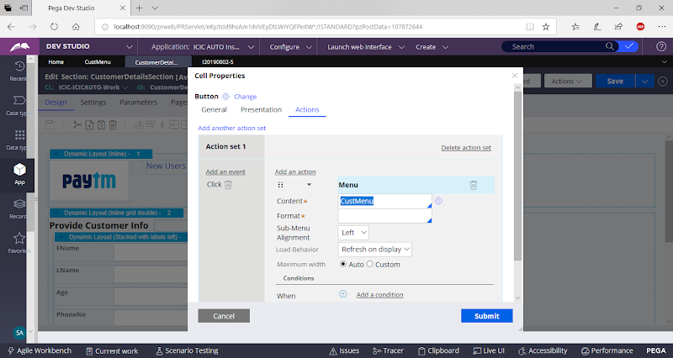

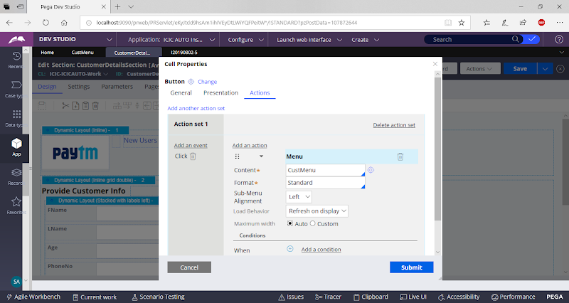

Click on Submit

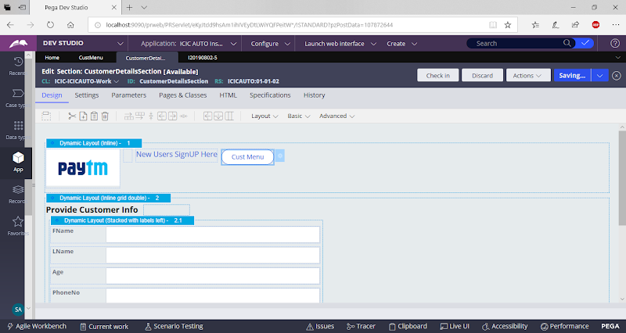

Save section